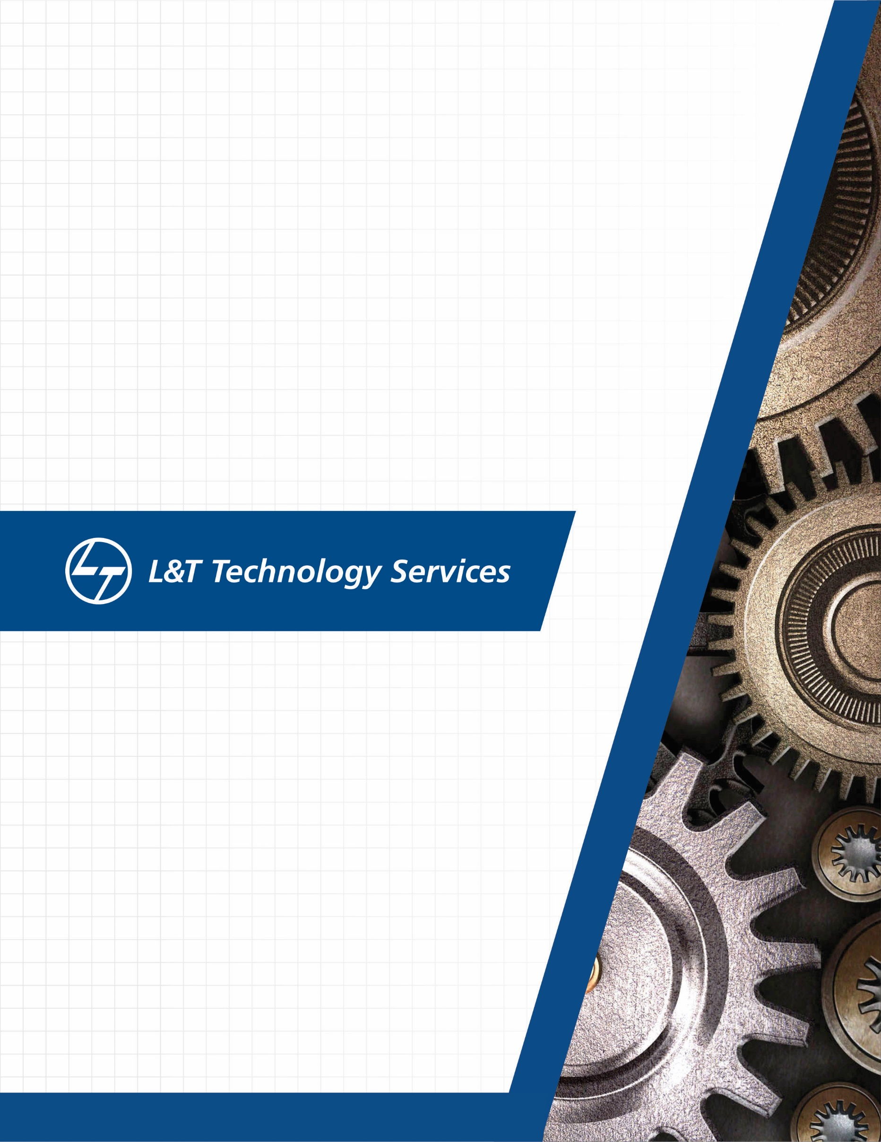SHADOW PROJECT –

CAT Embedded

./

SHADOW PROJECT –

CAT Embedded



|  |  |  |  |  |  |
| --- | --- | --- | --- | --- | --- |
| **Ver.Rel. No.** | **Release Date** | **Prepared. By** | **Reviewed By** | **Approved By** | **Remarks/Revision Details** |
| 1.1 | 11-05-2021 | ARPITA A KULKARNI |  |  | Added Tool Training and workflow, |
| 1.2 | 12-05-2021 | ARPITA A KULKARNI |  |  | Added TTT, LWL and Detailing of workflow. |

**Document History**

Contents

1. TOOL TRAINING 5

**1.1 Introduction to CANalyzer** 5

1.1.1 Main Window 5

1.1.2 Measurement Setup: 6

1.1.3 Analysis Window 7

1.1.4 Logging 10

1.1.5 CAN IG 11

**1.2** **Introduction to CAT ET** 11

1.2.1 STATUS PARAMETER 13

1.2.2 Measurement Setup 14

1.2.3 Configuration 15

1.2.4 Diagnostic test 16

**1.3 Introduction to CANape** 16

**1.4** **Introduction to TRACE32Powerview** 21

System Configuration 22

Target load 22

Watch window 22

List 22

Break Points 22

2.TRACTORS 22

2.1 Types of tractors 22

2.1.1 Track type 23

2.1.2 Wheel type 23

2.2 Classification of 4-Wheel type tractor 23

2.3 Different types of blade 24

• A Straight Blade 24

**2.4 TTT-Track Type Tractor** 25

**2.5 LWL- Large wheel loader** 26

3.Work flow Process 26

4.Work Completed 28

References 29

List of figure

Figure 1:Main window of CANalyzer 6

Figure 2:Measurement window 7

Figure 3:Chronological Display mode 7

Figure 4:Fixed Position Display mode 8

Figure 5: Graphics Window 8

Figure 6:Statistics Window 9

Figure 7:Data Window 10

Figure 8:Data logging 10

Figure 9:Interactive Generator 11

Figure 10: Main Window of CAT ET 12

Figure 11:Tool Bar Icons 12

Figure 12:Win Flashing 13

Figure 13:Status Parameter 14

Figure 14:Measurement Setup 14

Figure 15: Configuration in CAT ET 15

Figure 16: Diagnostic test 16

Figure 17: Create New Project in CANape 17

Figure 18:Measurement Window in CANape 21

Figure 19:system configuration in TRACE32 22

Figure 20:Track type tractor 23

Figure 21:Wheel type tractor 23

Figure 22: Straight Blade 24

Figure 23:U blade 24

Figure 24:S-U Blade 25

# 

# 1. TOOL TRAINING

## **1.1 Introduction to CANalyzer**

**CANalyzer** is an [analysis](https://en.wikipedia.org/wiki/Metrology) software tool from [Vector Informatik GmbH](https://en.wikipedia.org/wiki/Vector_Informatik). This development software is widely used, primarily by electronic control unit suppliers, to analyze the data traffic in serial bus systems. The most relevant bus systems here are [CAN](https://en.wikipedia.org/wiki/Controller_Area_Network), [LIN](https://en.wikipedia.org/wiki/Local_Interconnect_Network), [Flex Ray](https://en.wikipedia.org/wiki/FlexRay), [Ethernet](https://en.wikipedia.org/wiki/Ethernet) and [MOST](https://en.wikipedia.org/wiki/Media_Oriented_Systems_Transport)[[2]](https://en.wikipedia.org/wiki/CANalyzer#cite_note-2) as well as CAN-based protocols such as [J1939](https://en.wikipedia.org/wiki/J1939),[CANopen](https://en.wikipedia.org/wiki/CANopen),

CANalyzer is the comprehensive software tool with intuitive operation for analysis and stimulation of network communication. Use CANalyzer to check whether and what type of communication is occurring on the network. In addition to sending or recording data, interactive ECU diagnosis is also possible.

The integrated basic functions cover an abundance of potential uses. These include:

_ Listing of bus data traffic (tracing)

_ Graphic and textual display of signal values

_ Interactively sending out predefined messages

_ Sending out logged messages

_ Statistics on messages

_ Statistics on bus loading and bus faults

_ Logging of messages for offline evaluation

_ Generation of bus faults

### Main Window



Figure 1:Main window of CANalyzer

### Measurement Setup:

The data flow is graphically represented and configured in the Measurement Setup.

> **Define data source** (online/offline)

The simulated bus or the real bus connected via the hardware (e.g. CANcardXL) serves as the online data source. A file with logged data serves as the offline data source.

> **Insert analysis windows**

Data can be shown differently in the individual windows depending on analysis requirements, e.g. to graphically

represent signal waveforms or to display signal values.

> **Insert CAPL program nodes**

A CAPL program node can be used for such tasks as filtering data or implementing various arithmetic operations.

> **Insert trigger conditions**

Like filters, trigger conditions can also be used to reduce data. Triggers are specifically configured as a reaction to bus

events and can be combined with one another.

> **Log data**

For an analysis after the measurement, data can be logged in a logging file that can later be reused as an offline data

source and replayed.



Figure 2:Measurement window

### Analysis Window

As a CANalyzer user you can analyze the network communication of ECUs or entire systems at your work desk or right in the vehicle. These intelligent analysis windows support you:

1. **Trace Window** for listing all network activities such as messages or error frames. For each message there is the possibility of displaying the individual signal values.

1.**Chronological Display mode**



Figure 3:Chronological Display mode

**2.Fixed Position Display mode**



Figure 4:Fixed Position Display mode

**2.Graphics Window**for graphical online display for values transmitted in messages and diagnostic requests, such as rpm or temperature values, over a time axis.



Figure 5: Graphics Window

Symbols are Signals, Variables and Diagnostic Parameters

Symbols can be added to the Graphics Window via context menu or drag &drop

Various functions are available for highlighting/hiding curves and their measurement points

A Legend can be displayed

3.**Statistics Window** for displaying useful network and node statistics e.g. bus load on node and frame levels, burst counter/duration, counter/rate for frames and errors, controller states.

The Statistics Window shows statistical information about bus activities (CAN, LIN, FlexRay) during a measurement. This includes such information as bus load on node and frame level, burst counter/duration, counters/rates for frames and errors and controller states.

* Show statistical data of individual channels

The display of statistical data can be limited to a specific channel, or it can be configured for all available channels.

* Set updating interval

This is used to modify the interval for updating the display. Pause statistics

The display of statistical data can be paused during a measurement



Figure 6:Statistics Window

1. **Data Window:** Data Window for displaying preselected data, eg. numeric or bar graph data.

The Data Window is used to display the values of signals, system variables and diagnostic parameters in different types of representation.

* Show values

The data may be displayed as raw or symbolic values. Other display variants are scientific notation and the display of

global and local min/max values.

* Log data

Signals can be logged during the measurement and saved to MDF binary format.



Figure 7:Data Window

### Logging

Use CANalyzer to log data and replay them for post-measurement analysis. The import/export functions allow time-independent processing of the logged bus communication.  
Logging workflow with CANalyzer:

Logging is performed via special logging blocks in the measurement setup (1). You can also log directly from the Graphic Window and Data Window. The logged data can be played back into the system for offline analysis.

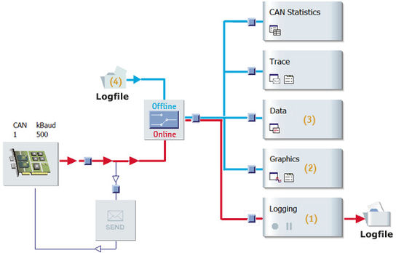

Figure 8:Data logging

### CAN IG

The Interactive Generator (IG) can be used to send messages as well as to set the corresponding signal values. This is an easy way to stimulate the bus.

* Define messages

Messages can be defined manually in the send list or with a database. The properties of the messages can be customized.

* Send messages

Messages which are configured in the send list can be sent periodically when a specific screen button is pressed or by pressing a predefined keyboard key.

* Change signal values

In the Interactive Generator, the raw data of each message can be modified in the signal list. For configured signals of a

specific message signal waveforms (signal curves) may be defined with the integrated Signal Generator. Raw data and

signal values can be easily sent with the associated message, e.g. to check the reaction of an ECU.

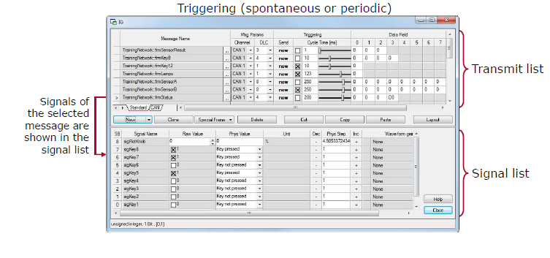

Figure 9:Interactive Generator

## **Introduction to CAT ET**

Cat ET is the program that customers use to diagnose and repair problems quickly.

Cat ET is a PC based service and electronic information tool which obtains information from electronically controlled Caterpillar equipment.

Flashing fls/fl2 files onto ECM

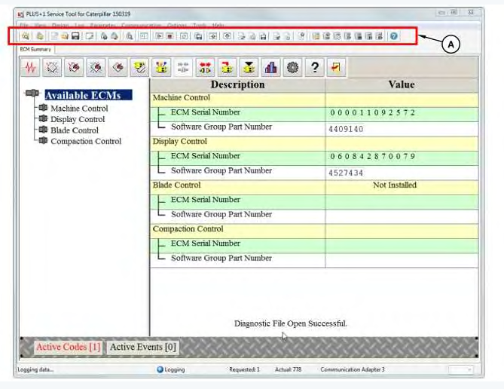

Figure 10: Main Window of CAT ET

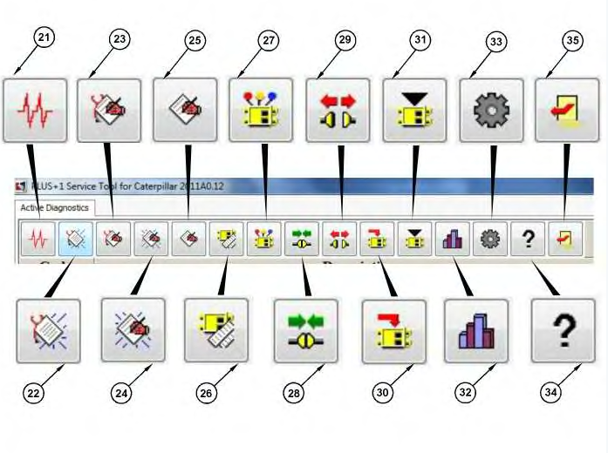

Figure 11:Tool Bar Icons

Tool Bar Icons Description  
(21) Status  
(22) Active Diagnostics  
(23) Logged Diagnostics  
(24) Active Events  
(25) Logged Events  
(26) ECM Summary  
(27) Configurations  
(28) Online Mode  
(29) Offline Mode  
(30) Flash  
(31) Calibrations  
(32) Current Totals  
(33) Menu  
(34) Help Contents  
(35) Exit

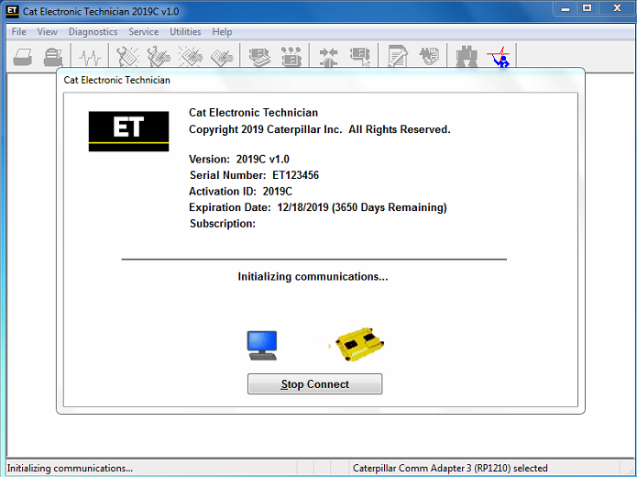

Figure 12:Win Flashing

### STATUS PARAMETER

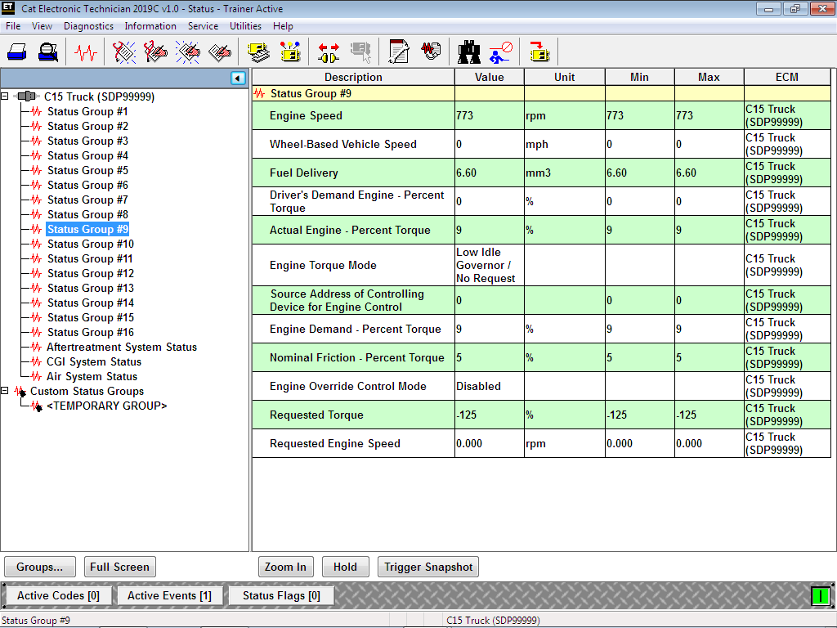

Figure 13:Status Parameter

### Measurement Setup

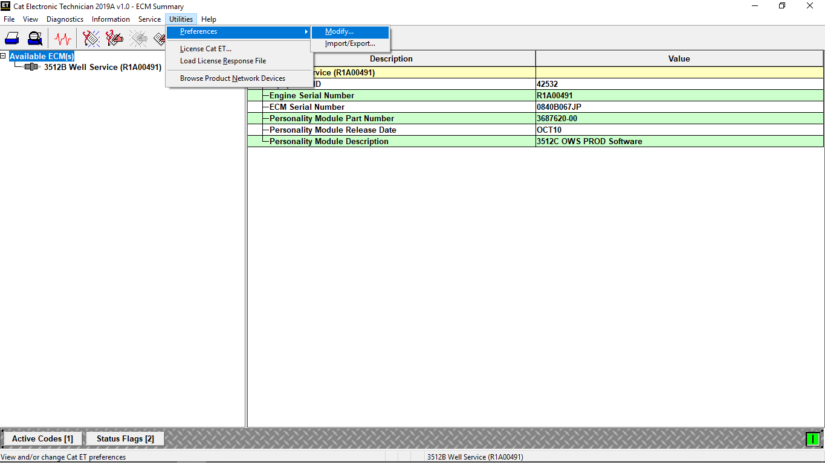

Figure 14:Measurement Setup

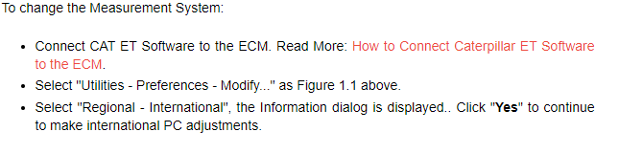

### 1.2.3 Configuration

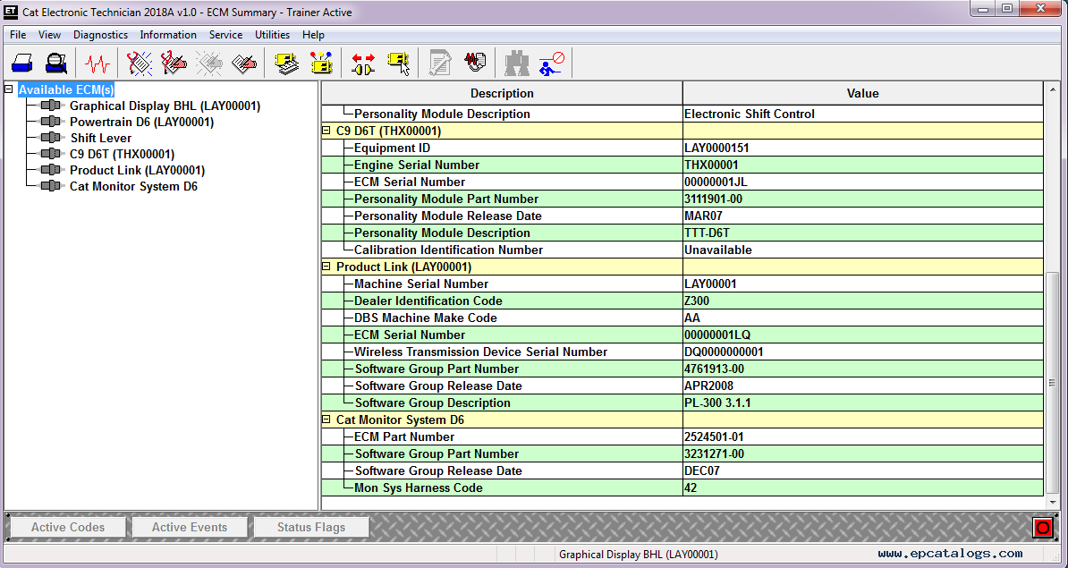

Figure 15: Configuration in CAT ET

### 1.2.4 Diagnostic test

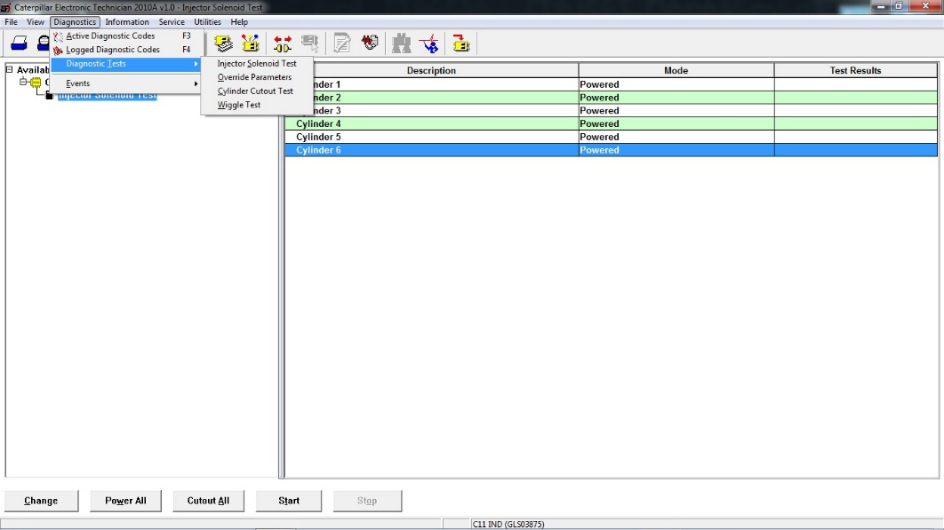

Figure 16: Diagnostic test

## **1.3 Introduction to CANape**

**CANape** is a software tool from [Vector Informatik](https://en.wikipedia.org/wiki/Vector_Informatik). This development software, widely used by OEMs and ECU suppliers is used to calibrate [algorithms](https://en.wikipedia.org/wiki/Algorithm) in [ECUs](https://en.wikipedia.org/wiki/Electronic_control_unit) at runtime.

* Configure hardware in vector Hardware found in control panel.
* Use A2L files.
* Inserting measurement signals.

The instructions also assume that CANcaseXL is used. If another communications device is used, the user may need to deviate from these instructions.

1. Start CANape and you will be asked to accept a disclaimer. After this you will see the following:

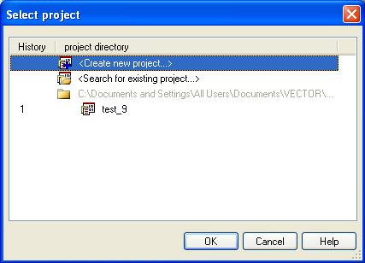

Figure 17: Create New Project in CANape

1. Select 'Create new project' and press 'OK'. You will then be asked for a project name. Enter a suitable name, click 'Next' and then browse to a suitable directory to save the project, click 'Next' and then 'Finish'. You should now see the following:

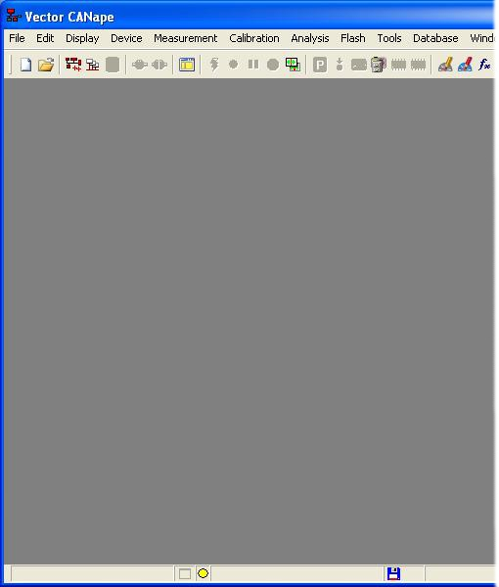

Select the menu option *Device->New from database...* and browse to where your model_name_canape.a2l file is located and select Open. If the device is connected correctly and configured with the appropriate baud rate, then you should see no errors or warning. The a2l file contains the CAN configuration as set by the model. It also has the relevant information for the flash, cal and RAM locations. CANape will use these values with no further configuration input required from the user.

If CCP seed/key security is required for an operation, the DLL implementing the appropriate key-generation algorithm must be placed in the same directory as the CANape project. Note that CCP seed/key security is disabled by default in the model_name_canape.a2l file.

Having set up the project (and CCP security if required), select the menu option *Flash->Download file to flash...* and browse to your built application, e.g., step1_m460_image_small.hex. Depending on the size of the memory region to be flashed, it may be necessary to increase the flash clear timeout parameter in CANape.

At the bottom left of the window the progress bar should be seen to advance until programming is complete.

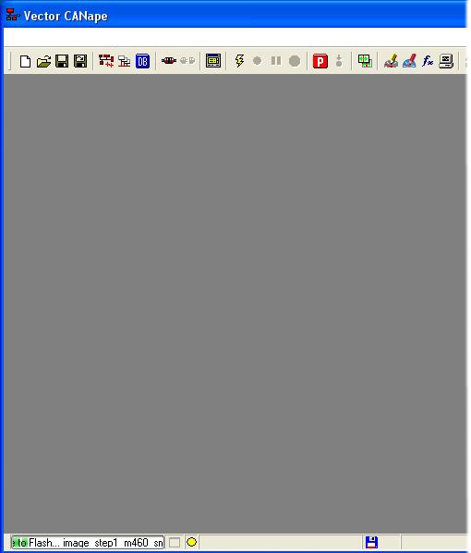

Next, select the menu option *Measurement->Measurement configuration...* and the following window will appear:

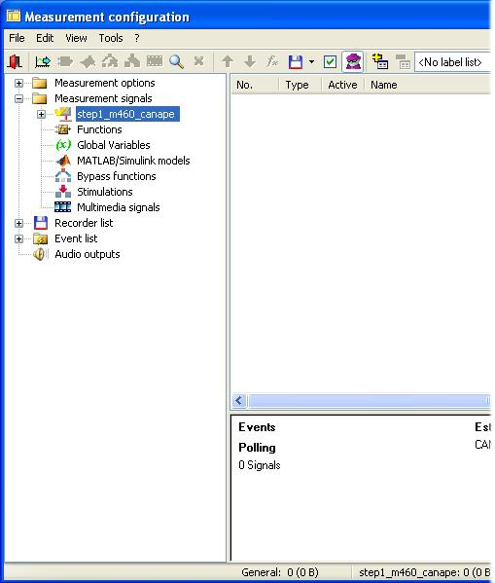

The Simulink model name should be visible in the left hand pane under 'Measurement signals'. Right click on the model name and select 'Insert signal' from the menu that appears. The Database selection window should then appear, listing all of the model signals and calibrateable values.

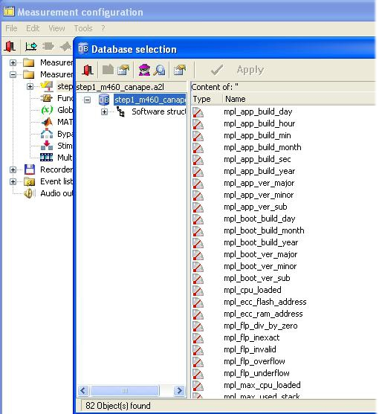

Double click on each signal of interest so that their text color changes to blue. Close both windows and accept changes and you will return to the main window. Now select the menu option *Display->Display windows->Numeric window*, an empty numeric display will appear. Right click on this numeric display and select 'Insert measurement signal...' the following appears:

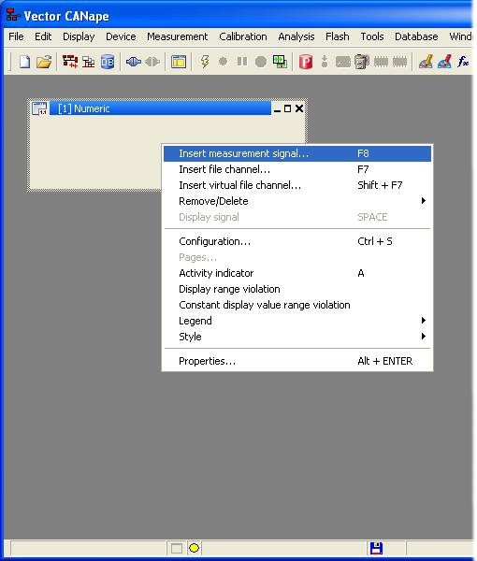

1. Next, right click and select 'Insert signal' on each parameter that you want to monitor in the numeric window

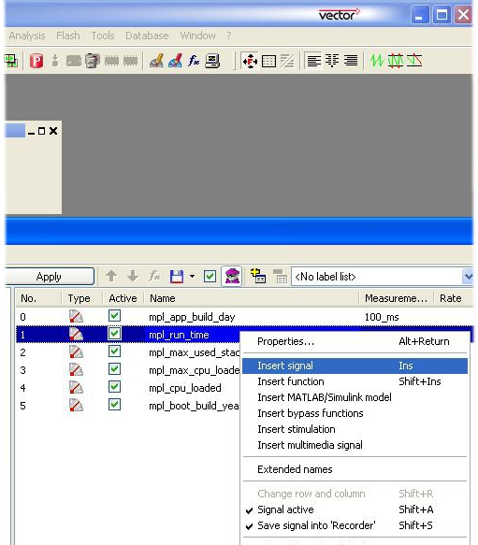

To access calibration values select the menu option *Display->Calibration windows->Calibration window*, then scroll down to find calibration parameters and select the ones that are required.

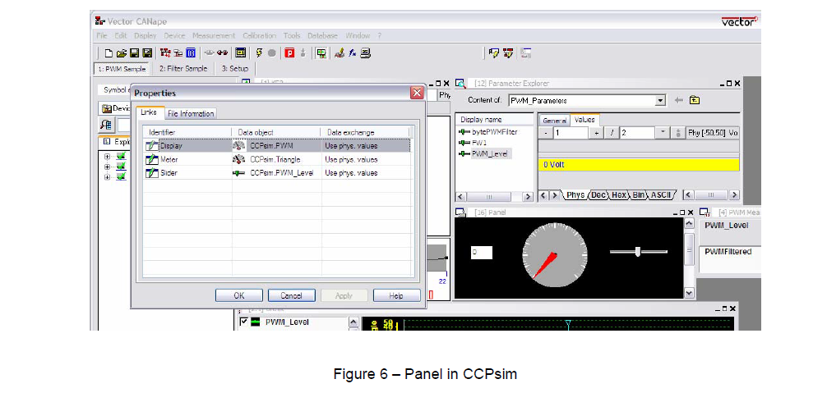

Figure 18:Measurement Window in CANape

## **Introduction to TRACE32Powerview**

TRACE32 debugger allows you to test your embedded hardware and software by using the on chip debug interface.

System Configuration: Initially it should be in no debug mode while flashing onto CAT ET.

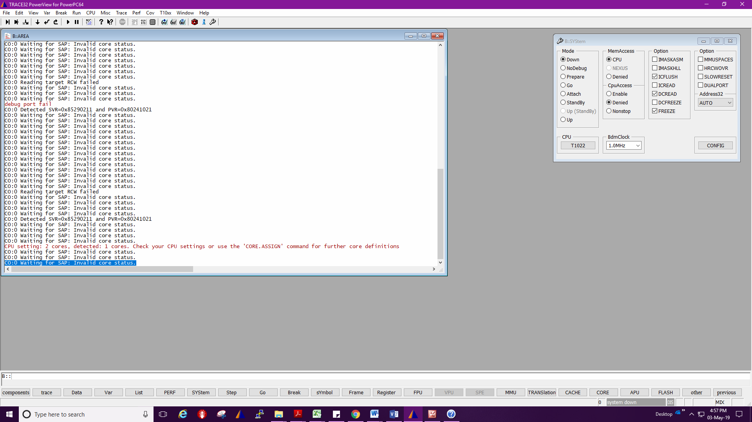

Figure 19:system configuration in TRACE32

Target load: First Reset followed by Depending of the target specification need to select target. Load the elf file load it then run.

Watch window: In Watch window we need to select the variables, symbols or functions to watch change in their value with respect to change in input.

List: We need to add source file path to add break points. Source file we can add using y.spath command To check how many source files are present. If unnecessary files are found, we can delete them.

Break Points: Break Points are added to check the execution of the function flow. Flow stops at break point, it becomes easy to trace out the error.

In Command line we can send the message, override the values, and output can be seen.

# 2.TRACTORS

## 2.1 Types of tractors

**Based on type of drive**

2.1.1 Track type

vehicle that runs on continuous tracks instead of wheels. Crawlers can range in size from machines with 75 horsepower that are less than 20,000 pounds and those with 900 horsepower that weigh almost 240,000 pound

Used in Field, off road landscapes

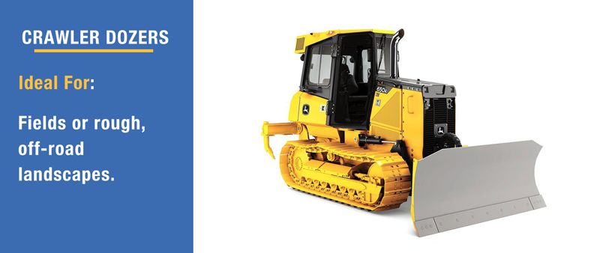

Figure 20:Track type tractor

### 2.1.2 Wheel type

It is an ideal choice for projects that require work in soft ground or sensitive surfaces, because tires inflict less disturbance on a surface than a track type. A wheel type is also a good choice for projects that require mobility and versatility.

The wheel tractor is generally bigger than a tracked tractor and it has articulated hydraulic steering and moves on a smaller axis.

Used in Large Mining operations, Road maintenance.

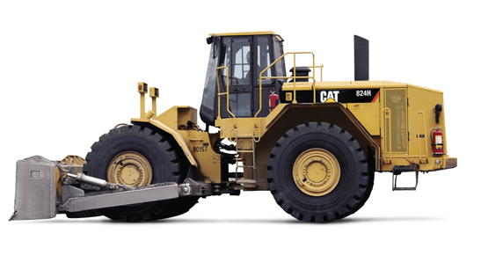

Figure 21:Wheel type tractor

## 2.2 Classification of 4-Wheel type tractor

A wheel loader is a four-wheeled machine used for earthmoving. Generally, it features a front-mounted bucket designed to scoop, hold and transport loosely packed materials, such as sand and dirt. This machine may also be called a skip loader, scoop loader, or even a bucket loader.

On the basis of available power, these have been classified as

(1) Small wheel loader /tractors – 15 to 25 hp.

(2) Medium wheel loader /tractors – 25 to 45 hp.

(3) Large wheel loader /tractors – more than 45 hp.

## 2.3 Different types of blade

* A Straight Blade ("S-Blade") which is short and has no lateral curve, no side wings, and can be used for fine grading.

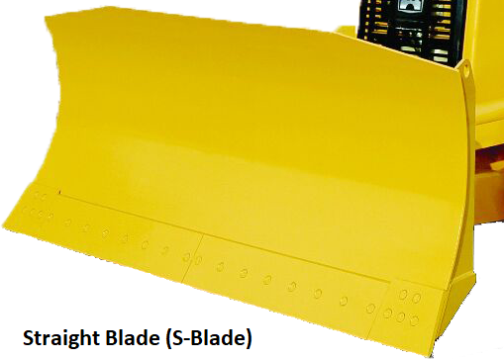

Figure 22: Straight Blade

* A Universal Blade ("U-Blade") which is tall and very curved, and has large side wings to carry more material. Used for Pushing, material handling, Hauling.

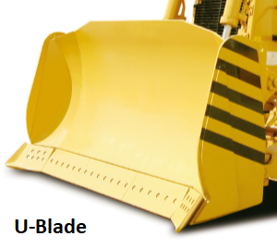

Figure 23:U blade

* A "S-U Blade" combination blade which is shorter, has less curvature, and smaller side wings.

The curve and wings reduce spillage and improves the carrying capabilities.

S-U blades are commonly used to push soft-to-medium sand and soil, but are also used in applications such as backfilling, stripping, stumping, leveling, and crowning.

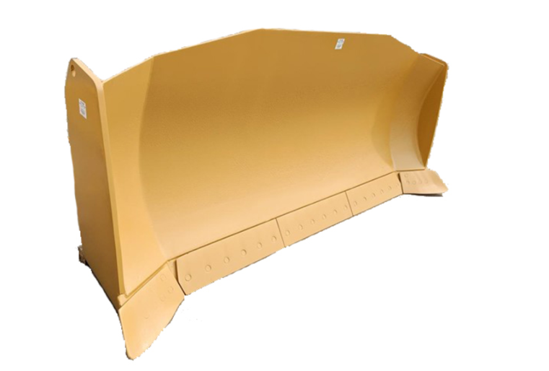

Figure 24:S-U Blade

## **2.4 TTT-Track Type Tractor**

A crawler tractor (track-type tractor/ track-laying vehicle)

In this type of tractors, one track is fitted on either side. This track gets drive from the sprocket run by rear axle shaft. To steer the tractor, there is no steering gear fitted.

While the basic operation of a tracked vehicle is similar to a wheeled vehicle, the main difference lies in steering. Instead of a steering wheel, a track vehicle utilizes a twin stick braking system. The operator applies the brake on the track in the direction of the turn. To turn right, the right track is stopped and the left track drives the vehicle to the right. For a left turn, the brake is applied to the left track and the right track pushes the vehicle around to the left

TTT have contact with a larger surface area than the wheeled tractor, and as a result exert a much lower force per unit area on the ground than a conventional wheeled tractor of the same weight.

Where it is used?

In agriculture they are used for land clearing and land leveling works.

Advantages of TTT

Low ground pressure

**Traction** - traction is very high including on slippery surfaces such as snow or wet concrete.

**Efficient energy** - in comparison to the wheels, the high performance tracks and the well-optimized traction system offer additional energy efficiency.

**Rough terrain** - tracked machines can work very well on rough terrain. They can climb and descend stairs, overcome obstacles or cross trenches.

**Weight distribution** - the weight of tracked tractors is very well distributed throughout its surface.

Disadvantages of TTT

**Low speed** - due to the much more complex mechanical system, tracked tractors have a much lower speed than those on wheels;  
 **More difficult to handle** - Tracked tractors are more precise in terms of maneuverability and require more rotational power;  
**Short life**- the life of the tracks is quite small, which is much more available at break or blocking.

Reduced steering control under heavy draft load.

Not compatible with loaders and dozers

## **2.5 LWL- Large wheel loader**

A large wheel loader could deliver over 900 horsepower. The top operating weight is over 290,000 lbs.

Loaders can also help to transport material around site. The larger wheel loaders are 7 – 8 yards.

A wheel loader is a piece of heavy machinery. It is a tractor-like cab fitted with four large tires and has a bucket loader at the front. It is used mainly for scooping and moving material in construction, agriculture, or landscaping industries. These machines are popular for loading gravel trucks or more heavy-duty projects

Advantages of LWL:

* Better turning under load
* Good compaction
* Better for dozing and loader applications
* Easier steering
* Less maintenance required
* Easier to change out tires for different uses
* Less cost upfront
* Faster transport

Disadvantages of LWL:

* Not great in muddy/wet conditions
* Higher slippage
* Bumpier ride than tracked, except on hard surfaces
* Possibility of going flat.

# 3.Work flow Process

* User story Analysis.

Need to check machine type and platform, depend on machine type location codes varies.

* Understanding Issue.

By its description need to understand the issue and Requirements.

* Download view for user story.

By doing GIT bash using command for particular machine, we can download source code.

* Code changes to meet the acceptance criteria.
* Push and commit in Git.

To know the code changes and can merge branch to origin during release.

* Build to get elf and fl2/fls files.

after code changes build to check on unit bench.

* Check for code changes on TRACE32 and CAT ET.

**Step 1**: Select WinFlash in CATET to load fl2/fls file. Modify Product ID in the ECM configuration tab

of the CAT ET tool.

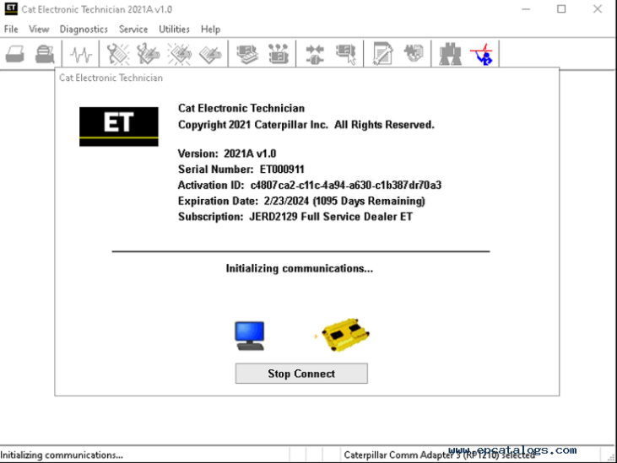

* **Step 2**: Connect Trace 32 debugger to the machine ECU and to the PC. Open the Trace 32 debugger application and setup as shown in the pictures below to select the file to download to the target.

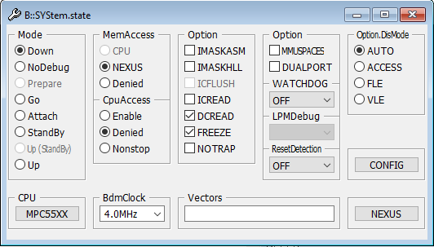

**Step 3**: Flash the elf file to the Machine ECM, Click the button next to Reset Target to load the application

Need to Check for Platform A5 or A6

**Step4**: Run

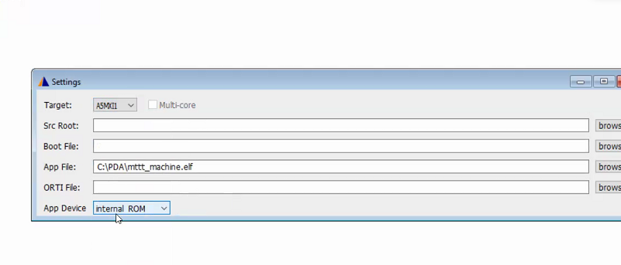

**Step 4:**If the need to put the breakpoint, then you can add the required source code files in the folder where .elf file is placed.

y.spath = Path

We can check source file by list view or using Symbol.spath.list

**Step 5:**Add watch variables if you want to see the values in real time.

For each variable there exist 3 parameter value, status and Override.

By Making override=1, we can change value and status accordingly.

**Step 6:** In Diagnosis-> Service test -> All the Set up condition to pass the test will be available and by pressing next we get to know result(passed/Error).

Output is checked for all different Input conditions until meet the acceptance criteria.

* Test Plan.

TestId, Input, Excepted Output, Actual Output and Result

* Test Report.
* Design summary.
* Code change summary.
* Submission of Activity for review.

# 4.Work Completed

User story No: 56231(TTT)

Machine Power Test changes (Submission of Activity for review).

User story No :3599 (LWL)

Functional Safety: Operator Not Present (Test Plan)

# References

For Canalyzer

<https://www.vector.com/int/en/products/products-a-z/software/canalyzer/>

For TRACE32

<https://www.google.com/search?q=trace32+user+guide&oq=trace32&aqs=chrome.0.69i59l2j69i57j69i59.2488j0j9&client=ms-android-xiaomi-rev1&sourceid=chrome-mobile&ie=UTF-8>

For TTT

<https://www.google.com/search?q=Advantages+and+disadvantages+of+wheel+loader&biw=1707&bih=781&sxsrf=ALeKk02WPT2_NLJuStx4_j5wQ0ftR2UBDg%3A1620888620133&ei=LMycYI3IB92D4-EPw_-Z6As&oq=Advantages+and+disadvantages+of+wheel+loader&gs_lcp=Cgdnd3Mtd2l6EAM6BwgjELADECc6BwgAEEcQsAM6BAghEApQsSFY_ypgiC5oAXACeACAAdEBiAGrBJIBBTAuMi4xmAEAoAEBqgEHZ3dzLXdpesgBBsABAQ&sclient=gws-wiz&ved=0ahUKEwiNjrHTiMbwAhXdwTgGHcN_Br0Q4dUDCA4&uact=5>

<https://www.cat.com/en_US/support/operations.html>

[FM1+1: Transmission of Power in a power tiller](http://ecoursesonline.iasri.res.in/mod/page/view.php?id=101030)

<https://en.m.wikipedia.org/wiki/Continuous_track>

<https://tractors.fandom.com/wiki/Crawler_tractor>

<https://www.pon-cat.com/en/products-1/dozers/medium-dozers/cat-d6t-track-type-tractor>

For LWL

<https://www.google.com/search?q=Large+wheel+loader+vehicle&oq=large+wheel+loader+vehicle&aqs=chrome.0.69i59.3290j0j7&sourceid=chrome&ie=UTF-8>

<https://www.nbmcw.com/product-solutions/construction-equipments/earthmoving-road-construction-equipment/wheel-loader-an-exclusive-loading-equipment-machinery.html>

<https://www.elephantmachinery.com/news/advantages-and-disadvantages-of-wheel-loader-11113087.html>

<https://www.cat.com/en_IN/products/new/equipment/wheel-loaders.html>